**GEAR DESIGN AND ANALYSIS TOOL**

* Calculate gear ratio and speed torque and efficiency
* **Inputs:** number of gear teeth, input speed and torque
* **Outputs:** output speed torque efficiency
* **Libraries:** numpy and matplotlib
* **Extension:** stress strain analysis on gear teeth using lews equation

Code:

driven=int(input("enter the number of drive gear teeth:"))

driver=int(input("enter the number of driver gear teeth:"))

gearratio=driven/driver

print("gear ratio:",gearratio)

drivenspeed=int(input("enter speed of driven gear:"))

driverspeed=int(input("enter the speed of driver gear:"))

speed=drivenspeed/driverspeed

print("gearratio",speed,"RPM")

torque=int(input("enter input torque:"))

outputtorque=gearratio*torque

print("torque of gear is:",outputtorque,"Nm")

inputtorque=float(input("enter input torque Nm:"))

efficiency=outputtorque/inputtorque*100

print("efficiency of gear is:",efficiency,"%")

import matplotlib.pyplot as plt

x = [750,100]

y = [51,12]

plt.plot(x, y, marker='o', linestyle='-', color='b', label='Prime Numbers')

plt.title('SPEED VS TORQUE')

plt.xlabel('X-axis')

plt.ylabel('Y-axis')

plt.legend()

plt.grid(True)

plt.show()

**OUTPUT:**

enter the number of drive gear teeth:56

enter the number of driver gear teeth:23

gear ratio: 2.4347826086956523

enter speed of driven gear:700

enter the speed of driver gear:4

gearratio 175.0 RPM

enter input torque:34

torque of gear is: 82.78260869565219 Nm

enter input torque Nm:12

efficiency of gear is: 689.8550724637682 %

**MODEL GRAPH:** 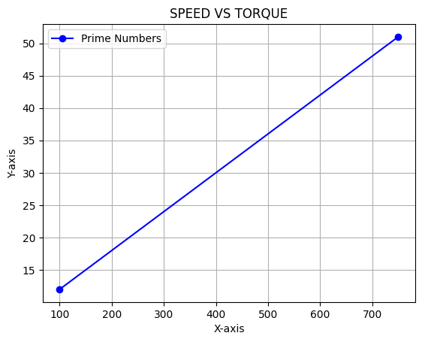

**CONCLISION:**

A **gear train** is a mechanical system consisting of two or more gears working together to transmit motion and torque from one shaft to another. Gear trains are essential in machinery because they allow for changes in speed, torque, and direction of rotation.